ENGR101 AVC PLAN
02/05/2018

Team Roster
Name | ID | Cell | Email | Role
Phillip  Lange | 300408406 | 0212050023 | langepj@gmail.com | Software Lead
Alexander Saunders | 300291379 | 0212155922 | alex.collet.saunders@gmail.com | Hardware Lead
George  Ravenhall | 300459325 | 0226647812 | gravenhall32@gmail.com | Hardware
Aezielle  Zapanta | 300454271 | 0273090921 | dudaizapanta@gmail.com | Software
Pragya  Pradhan | 300442687 | 0223422511 | pragya.prad27@gmail.com | Hardware
Jakub  Miksa | 300465384 | 0211369136 | miksa.kuba@gmail.com | Software

Team Working Times:
Wednesday 10-12
Friday 16-18

Team Communication:
Team: https://discord.gg/mPGBB79
General: https://discord.gg/GPtvtK4

Version Control:
Git: https://github.com/Langepj/ENGR101-AVC

Deliverables Timeline
Date | Hardware | Software
02/05/2018 | - Basic Plan  - Test Boards  - Sketches | - Basic Logic  - Planning
02/05/2018 | - Agreement on number of sensors/motors  - Timeline drawn up  - Overall plan ready for hand-in
04/05/2018 | - CAD Prototype  - Begin 3D-Print  - Progress Photos | - Set-Up Git  - Set-Up G-Drive  - Flow Chart
9/05/2018 | - Rolling prototype complete  - Test hardware of rolling prototype  - 3D CAD lessons | - Begin work on clearing first section (straight line)
11/05/2018 | - Goals/criteria for design  - First concepts | - Robot clears first section.  - Begin work in second section (masking tape curves).
16/05/2018 | - Select design  - Begin CAD | - Robot clears second section.  - Begin work on third section (masking tape maze).
18/05/2018 | - Manufacture (3D printing, drilling tapping etc.)  - Assembly  - Progress report (due 21/5) | - Continue working on masking tape maze if necessary or start on walled maze.  - Progress report (due 21/5)
23/05/2018 | - Troubleshooting | - Robot clears third section  - Robot clears forth section
28/05/2018 | - Robot Testing  - Final report (due 11/6)
30/05/2018 | - Panic | - Panic
11/06/2018 | - Final report due

Conflicts and Commitments
Phillip
CYBR171 MidTerm 09/05/18
SWEN221 MidTerm 13/05/18
SWEN221 and NWEN241 Assignments (13/05 && 16/05)
Student Academic Committee 31/05/2018

Saunders
CYBR171 MidTerm 09/05/18
COMP102 Terms Test 2 14/05/2018
ENGR121 Test 2 25/05/2018

Pragya
CYBR171 Midterm 09/05/18
COMP102 Assignments (10/05/018, 24/05/018 & 31/05/018)
ENGR121 Assignment (11/05/018)
ENGR121 Test 2 (25/05/018)

George
CYBR171 Midterm 09/05/18
COMP112 Assignments (10/05/18, 17/05/18, 24/05/18 & 31/05/18)
ENGR121 Assignment (11/05/18)
ENGR121 Test 2 (25/05/18)
Aezielle
CYBR171 Midterm 09/05/18
COMP102 Assignments (10/05/18, 24/05/18 & 31/05/18)
ENGR121 Assignment (11/05/18)
ENGR121 Test 2 (25/05/18)

Jakub
COMP112 Assignments (10/05/18, 17/05/18, 24/05/18 & 31/05/18)
COMP112 Test 2 (14/05/18)
INFO151 Assignments (11/05/18, 25/05/18)
INFO151 Quiz 2 (28/05/18)
Stanford University Machine Learning Assignments (07/05/18, 14/05/18, 21/05/18)
DeepLearning.ai Neutral Networks and Deep Learning Assignments (14/05/18, 21/05/18, 28/05/18)

Team Agreement

By signing below, all team members are acknowledging that they have read and committed to their part in the AVC. They acknowledge that they will attempt to complete the tasks agreed on by the group each week and document this on the team github account. They acknowledge that failure to meet these goals can result in the team recommending any member receives a lesser grade for their AVC report. In the event that a team member is unable to complete their task due to circumstances beyond their control (i.e. sickness, bereavement etc) that they will inform the team at the earliest possible time. Finally, the team acknowledges that a member going a week without contact with other team members (except when discussed with the team in advance) will constitute the member in question being considered AWOL. In this instance the team agrees to inform the ENGR101 course coordinator immediately. The penalty this for this can range from a reduction in the final grade to immediate failure of the AVC (and thus the ENGR101 course). Should the team unanimously agree that a member (or members) have failed to contribute to the AVC sufficiently for other reasons, on the day of robot testing the team will be given the opportunity to anonymously vote for a team member to receive 0% for the robot part of the AVC. Should the team choose this option they MUST be able to show that the member in question had been assigned tasks that they failed to complete and that the team had afforded them an opportunity to make up for past mistakes.

Signed by all team members:

Phillip Lange

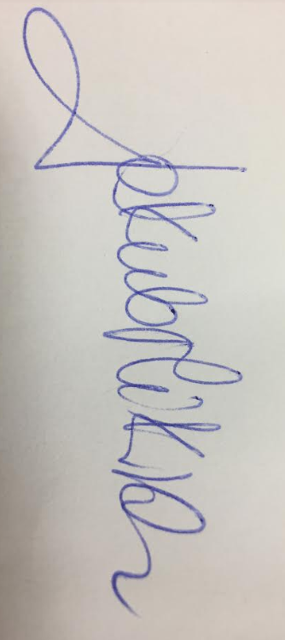

Jakub Miksa
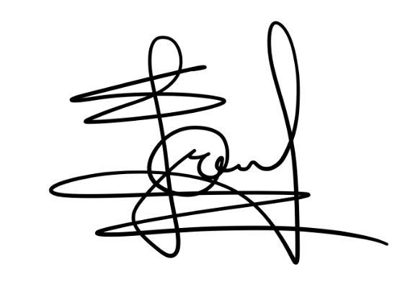
Pragya Pradhan

George Ravenhall



Alexander Saunders


Aezielle Zapanta

